“PL-SQL -- Exercise 1: Control Structures”
Scenario 1: The bank wants to apply a discount to loan interest rates for customers above 60 years old.
  - Question: Write a PL/SQL block that loops through all customers, checks their age, and if they are above 60, apply a 1% discount to their current loan interest rates.
SOLUTION:
BEGIN
FOR cust_rec IN (
SELECT l.LoanID, l.InterestRate, c.DOB
FROM Loans l
JOIN Customers c ON l.CustomerID = c.CustomerID
) LOOP
-- Print initial status
DBMS_OUTPUT.PUT_LINE('Loan ID: ' || cust_rec.LoanID ||
' | Original Interest Rate: ' || cust_rec.InterestRate);
-- Check age
IF TRUNC(MONTHS_BETWEEN(SYSDATE, cust_rec.DOB) / 12) > 60 THEN
-- Apply 1% discount
UPDATE Loans
SET InterestRate = cust_rec.InterestRate - (cust_rec.InterestRate*0.01)
WHERE LoanID = cust_rec.LoanID;
-- Print updated status
DBMS_OUTPUT.PUT_LINE('→ Updated Interest Rate for Loan ID ' || cust_rec.LoanID ||
' to ' || TO_CHAR(cust_rec.InterestRate - 1));
DBMS_OUTPUT.PUT_LINE('----------------------------------------------------');
ELSE
DBMS_OUTPUT.PUT_LINE('→ No change (Customer under 60)');
DBMS_OUTPUT.PUT_LINE('----------------------------------------------------');
END IF;
END LOOP;
COMMIT;
END;
/
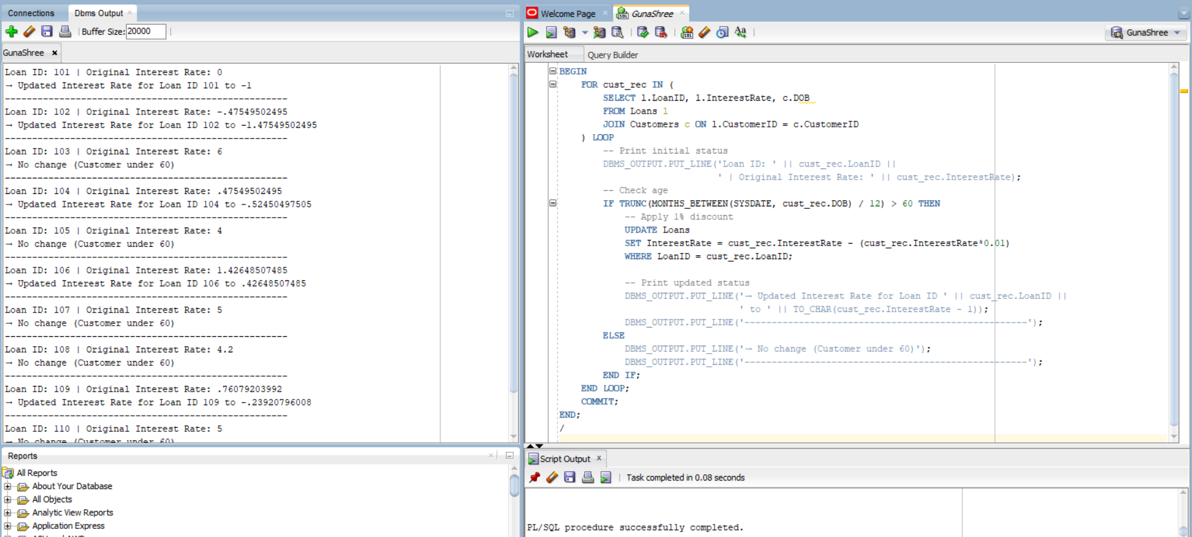


--------------------------------------------------------------------------------------------------------------------------------------

Scenario 2: A customer can be promoted to VIP status based on their balance.
  - Question: Write a PL/SQL block that iterates through all customers and sets a flag IsVIP to TRUE for those with a balance over $10,000.
SOLUTION:
SET SERVEROUTPUT ON;
ALTER TABLE Customers ADD IsVIP VARCHAR2(5);
BEGIN
FOR cust_rec IN (
SELECT CUSTOMERID, BALANCE
FROM CUSTOMERS
) LOOP
-- Print balance and VIP status before update
DBMS_OUTPUT.PUT_LINE('Customer ID: ' || cust_rec.CustomerID ||
' | Balance: ' || cust_rec.Balance);
IF cust_rec.BALANCE > 10000 THEN
UPDATE CUSTOMERS
SET IsVIP = 'TRUE'
WHERE CUSTOMERID = cust_rec.CUSTOMERID;
DBMS_OUTPUT.PUT_LINE('→ IsVIP status set to TRUE');
DBMS_OUTPUT.PUT_LINE('----------------------------------------------------------');
ELSE
UPDATE CUSTOMERS
SET IsVIP = 'FALSE'
WHERE CustomerID = cust_rec.CUSTOMERID;
DBMS_OUTPUT.PUT_LINE('→ IsVIP status set to FALSE');
DBMS_OUTPUT.PUT_LINE('----------------------------------------------------------');
END IF;
END LOOP;
COMMIT;
END;
/

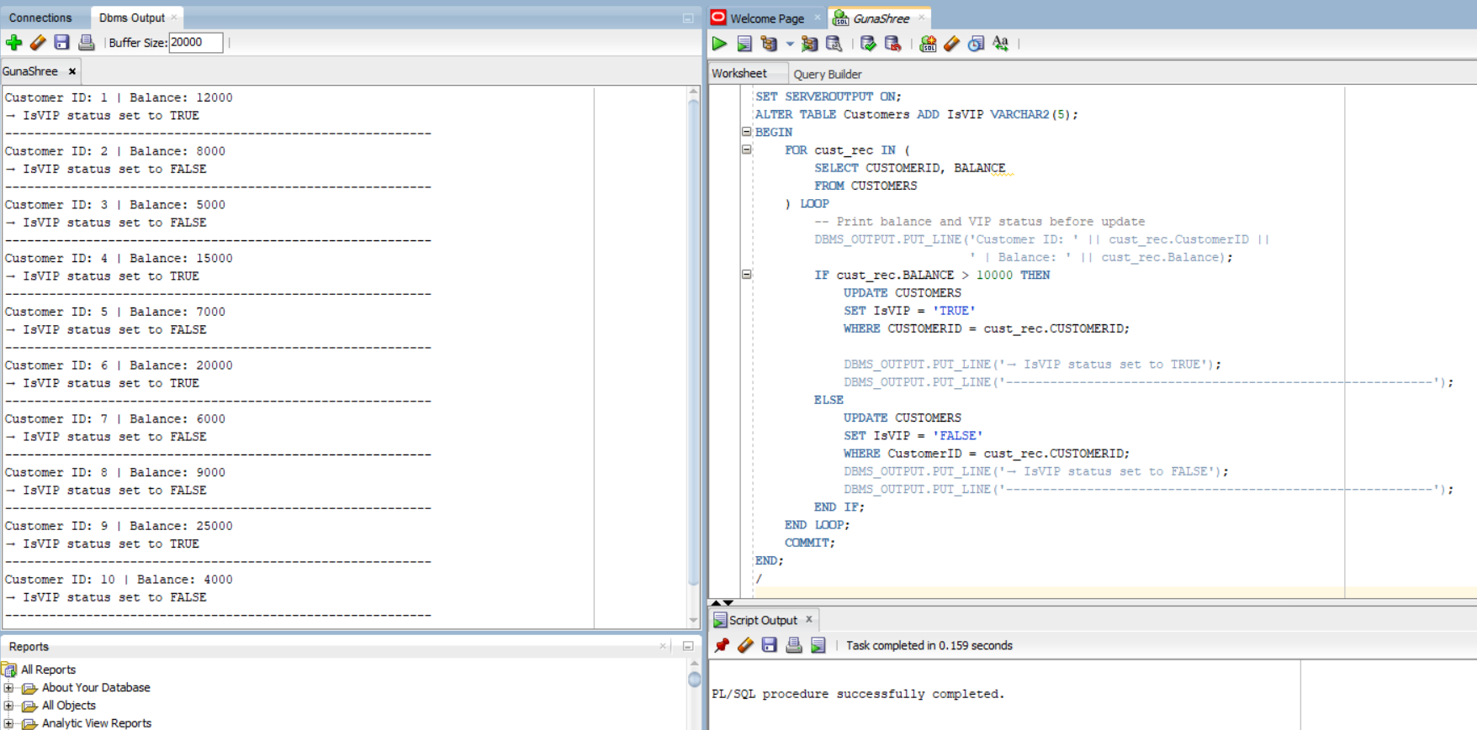


Scenario 3: The bank wants to send reminders to customers whose loans are due within the next 30 days.
Question: Write a PL/SQL block that fetches all loans due in the next 30 days and prints a reminder message for each customer.
SOLUTION:
BEGIN
FOR rec IN (
SELECT l.LoanID, l.EndDate, c.Name FROM Loans l
JOIN Customers c ON l.CustomerID = c.CustomerID
WHERE l.EndDate BETWEEN SYSDATE AND SYSDATE + 30
) LOOP
DBMS_OUTPUT.PUT_LINE(
'Reminder: Dear ' || rec.Name || ', your loan (Loan ID: ' || rec.LoanID ||
') is due on ' || TO_CHAR(rec.EndDate, 'DD-MON-YYYY') ||
'. Please ensure timely repayment.' );
END LOOP;
END;
/
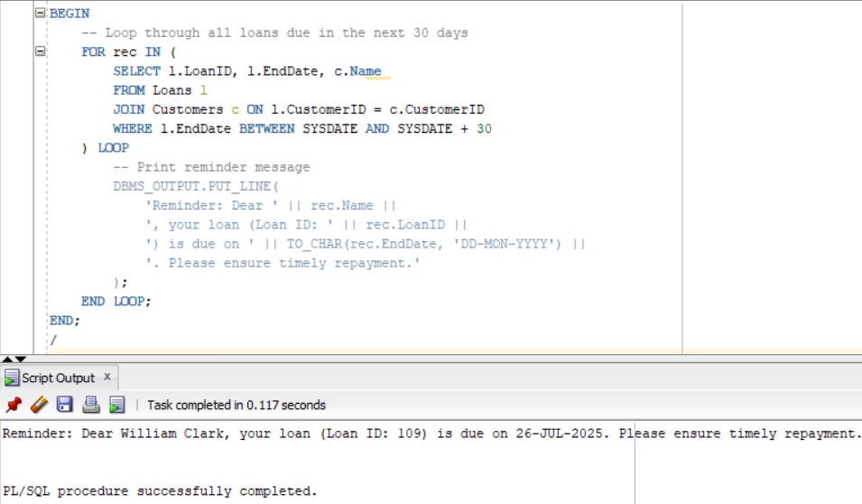
---------------------------------------------------------------------------------------------------------------------------

“PL-SQL -- Exercise 3: Stored Procedures”
Scenario 1: The bank needs to process monthly interest for all savings accounts.
  - Question: Write a stored procedure ProcessMonthlyInterest that calculates and updates the balance of all savings accounts by applying an interest rate of 1% to the current balance.
SOLUTION:
SET SERVEROUTPUT ON;
CREATE OR REPLACE PROCEDURE ProcessMonthlyInterest AS
v_new_balance NUMBER;
BEGIN
DBMS_OUTPUT.PUT_LINE('--- Monthly Interest Processing Started ---');
-- Loop through all savings accounts
FOR acc_rec IN (
SELECT AccountID, Balance
FROM ACCOUNTS
WHERE AccountType = 'Savings'
) LOOP
-- Calculate new balance
v_new_balance := acc_rec.Balance + (acc_rec.Balance * 0.01);
-- Show before and after in output
DBMS_OUTPUT.PUT_LINE('Account ID: ' || acc_rec.AccountID);
DBMS_OUTPUT.PUT_LINE(' Before: Rs. ' || acc_rec.Balance);
DBMS_OUTPUT.PUT_LINE(' After: Rs. ' || TO_CHAR(v_new_balance, '9999990.00'));
DBMS_OUTPUT.PUT_LINE('--------------------------------------------------------------------');
-- Update the balance
UPDATE Accounts
SET Balance = v_new_balance,
LastModified = SYSDATE
WHERE AccountID = acc_rec.AccountID;
END LOOP;

COMMIT;
DBMS_OUTPUT.PUT_LINE('--- Monthly Interest Processing Completed ---');
END;
/
EXEC ProcessMonthlyInterest;
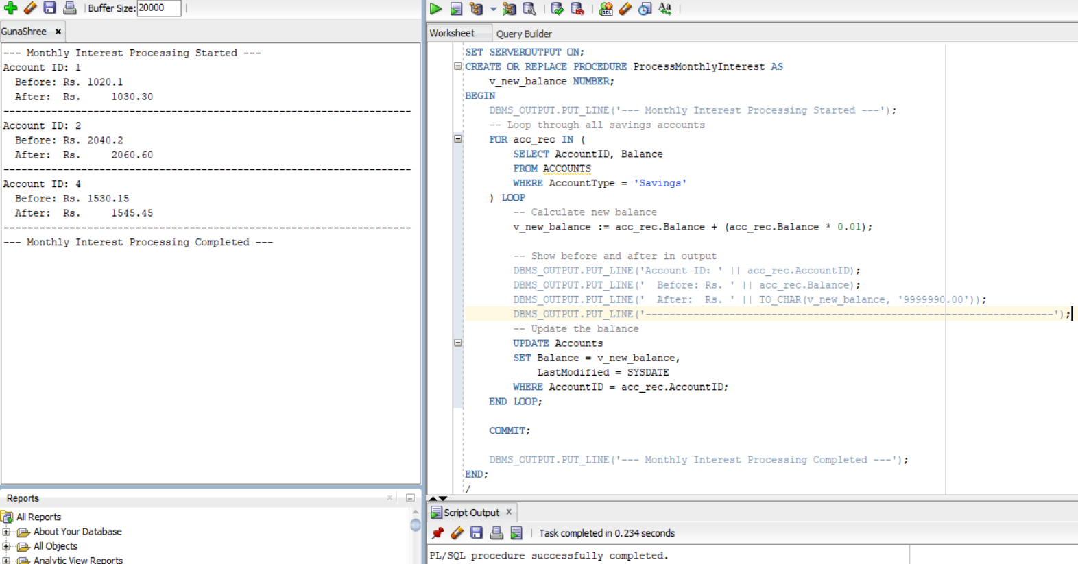


---------------------------------------------------------------------------------------------------------------------------
Scenario 2: The bank wants to implement a bonus scheme for employees based on their performance.
- Question: Write a stored procedure UpdateEmployeeBonus that updates the salary of employees in a given department by adding a bonus percentage passed as a parameter.
SOLUTION:
SET SERVEROUTPUT ON;
CREATE OR REPLACE PROCEDURE UpdateEmployeeBonus (
p_department IN VARCHAR2,
p_bonus_pct IN NUMBER -- e.g., pass 10 for 10%
) AS
v_bonus_amt NUMBER;
BEGIN
DBMS_OUTPUT.PUT_LINE('--- Bonus Update for Department: ' || p_department || ' ---');
FOR emp_rec IN (
SELECT EmployeeID, Department, Salary
FROM Employees
WHERE Department = p_department
) LOOP
-- Calculate bonus
v_bonus_amt := emp_rec.Salary * (p_bonus_pct / 100);
-- Display ID, Dept, and Bonus
DBMS_OUTPUT.PUT_LINE('ID: ' || emp_rec.EmployeeID ||
' | Dept: ' || emp_rec.Department ||
' | Bonus: ' || TO_CHAR(v_bonus_amt, '999999.00'));
-- Update salary
UPDATE Employees
SET Salary = Salary + v_bonus_amt
WHERE EmployeeID = emp_rec.EmployeeID;
END LOOP;

COMMIT;
DBMS_OUTPUT.PUT_LINE('--- Bonus Applied Successfully ---');
END;
/
EXEC UpdateEmployeeBonus('IT',10);
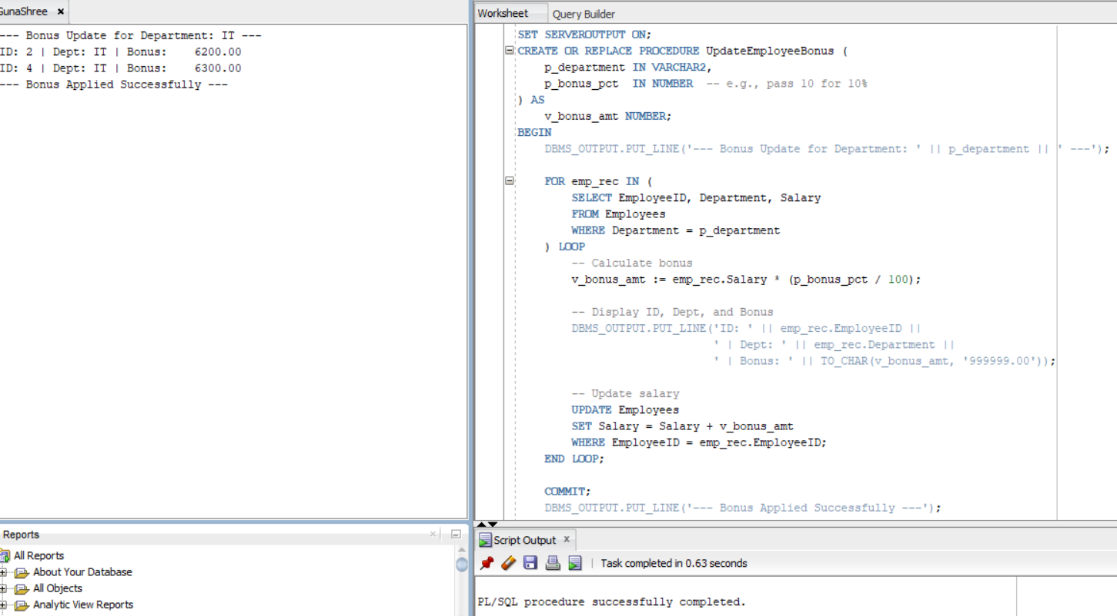


---------------------------------------------------------------------------------------------------------------------------

Scenario 3: Customers should be able to transfer funds between their accounts.
  - Question: Write a stored procedure TransferFunds that transfers a specified amount from one account to another, checking that the source account has sufficient balance before making the transfer.
SOLUTION:
SET SERVEROUTPUT ON;
CREATE OR REPLACE PROCEDURE TransferFunds (
p_source_account_id IN NUMBER,
p_destination_account_id IN NUMBER,
p_amount IN NUMBER
) AS
v_source_balance_before NUMBER;
v_destination_balance_before NUMBER;
v_source_balance_after NUMBER;
v_destination_balance_after NUMBER;
BEGIN
DBMS_OUTPUT.PUT_LINE('--- Transfer Initiated ---');

-- Step 1: Get balances before transfer
SELECT Balance INTO v_source_balance_before
FROM Accounts
WHERE AccountID = p_source_account_id;

SELECT Balance INTO v_destination_balance_before
FROM Accounts
WHERE AccountID = p_destination_account_id;

DBMS_OUTPUT.PUT_LINE('BEFORE TRANSFER:');
DBMS_OUTPUT.PUT_LINE('Source Account (ID ' || p_source_account_id || '): Rs. ' || v_source_balance_before);
DBMS_OUTPUT.PUT_LINE('Destination Account (ID ' || p_destination_account_id || '): Rs. ' || v_destination_balance_before);

-- Step 2: Check if source account has sufficient balance
IF v_source_balance_before < p_amount THEN
RAISE_APPLICATION_ERROR(-20001, 'Insufficient balance in source account.');
END IF;
-- Step 3: Perform the transfer
UPDATE Accounts
SET Balance = Balance - p_amount,
LastModified = SYSDATE
WHERE AccountID = p_source_account_id;

UPDATE Accounts
SET Balance = Balance + p_amount,
LastModified = SYSDATE
WHERE AccountID = p_destination_account_id;
-- Step 4: Get balances after transfer
SELECT Balance INTO v_source_balance_after
FROM Accounts
WHERE AccountID = p_source_account_id;
SELECT Balance INTO v_destination_balance_after
FROM Accounts
WHERE AccountID = p_destination_account_id;

DBMS_OUTPUT.PUT_LINE('AFTER TRANSFER:');
DBMS_OUTPUT.PUT_LINE('Source Account (ID ' || p_source_account_id || '): Rs. ' || v_source_balance_after);
DBMS_OUTPUT.PUT_LINE('Destination Account (ID ' || p_destination_account_id || '): Rs. ' || v_destination_balance_after);
COMMIT;

DBMS_OUTPUT.PUT_LINE('Transfer of Rs. ' || p_amount || ' completed successfully.');
DBMS_OUTPUT.PUT_LINE('-----------------------------');
EXCEPTION
WHEN NO_DATA_FOUND THEN
RAISE_APPLICATION_ERROR(-20002, 'One of the accounts does not exist.');
WHEN OTHERS THEN
ROLLBACK;
RAISE;
END;
/
BEGIN
TransferFunds(1, 2, 500); -- Transfer ₹500 from AccountID 1 to 2
END;
/




